TRUCK LOAD PLANNING

The first part of truck load planning is to understand the release status codes for each delivery. We like to refer to the Release Folder as the “Scheduled” Release Delivery Folder. Whereas the O-T-1 screen are normally actual releases scheduled for delivery. So under this definition, the O-U-1-Release Folder would have a future or planned delivery date, whereas O-T-1 are releases which would normally ship within days. Scheduled releases may have multiple shipping locations, multiple dates and multiple purchase order numbers for the same item on an order.

Scheduled Release status codes may be “S”cheduled, “Late” or “I”nvoiceable. Actual Release codes are “A”ctual, “B”ackordered. Once the actual release has posted, the status changes to “P”osted and normally is found in the bill of lading file. Once the bill of lading is posted, the status changes to “Z” status for shipped complete and invoice created and is then found in the invoice file. If the bill of lading is partially shipped, the partial quantity release will have a status of “B”ackorder and will be found in O-T-1. When the invoice is posted, the release status changes to “C”.
In summary the status codes are the following:

S- Scheduled – Scheduled release based on date. Find in O-U-1-Release Folder.
L- Late – Late release. Current date past due date. Find in O-U-1-Release Folder
I- Invoice Now – Invoice release. Date past Last Ship date in O-U-1-Release Folder.
A- Actual – Actual release. Find in O-T-1 Actual release file.
P - Posted – Actual release Posted. Find in O-S-1 bill of lading file.
B- Backorder - Bill of Lading Posted. Find partial release in O-T-1.
Z- Completed - Bill of Lading Posted. Find in O-B-1 invoice file or invoice posted.
C- Invoiced - Invoice Posted . Must find in inquiries or Invoiced Releases.

ORDER ENTRY - ITEMS TAB

If a finished goods line item is added without an estimate, the count imports from the finished goods file. If the item is created from an estimate, the quantity per unit and units per pallet are transferred from the estimate. Please note, unit may be a case, bundle or pallet count. If you ship by the pallet then the units per Pallet will be 1.
However, if you ship cases or bundles, then the units/Pallets will be how many cases or bundles per pallet. The counts are downloaded to the actual release if the user does not pick specific pallets tags for the delivery.

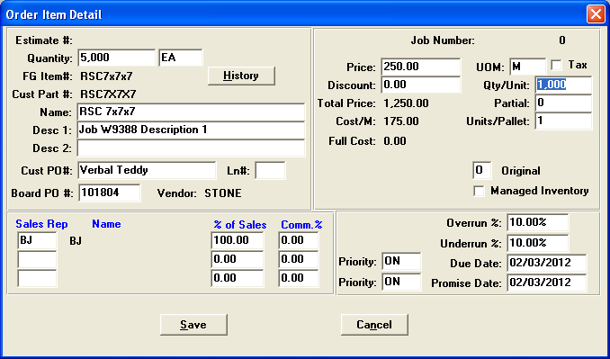

ORDER ENTRY – RELEASE FOLDER TAB

The Release folder allows changing the quantity for each release. The Release Button provides the option to select specific pallet tags or just the release quantity without pallet tags. If you select pallet tags, then the system knows the exact pallet numbers and total number of pallets. If you select NO TAGS, then once released, the quantity and pallet count are transferred from the Items folder. Thus the quantity divided by count will equal the number of pallets for the truck load summary report.

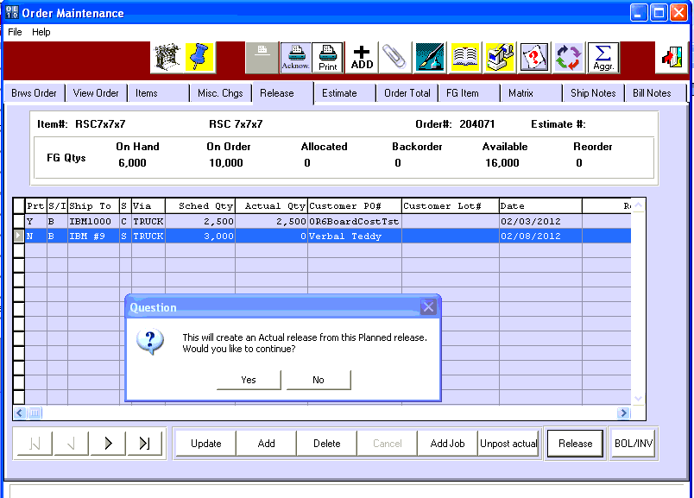

ORDER ENTRY – ACTUAL RELEASE FOLDER (O-T-1)

The Actual Release will display the total number of pallets for this delivery based on the release quantity. If specific pallet were chosen, then each line would have just 1 pallet. The total number of pallets for all lines will be downloaded to the truck summary program.

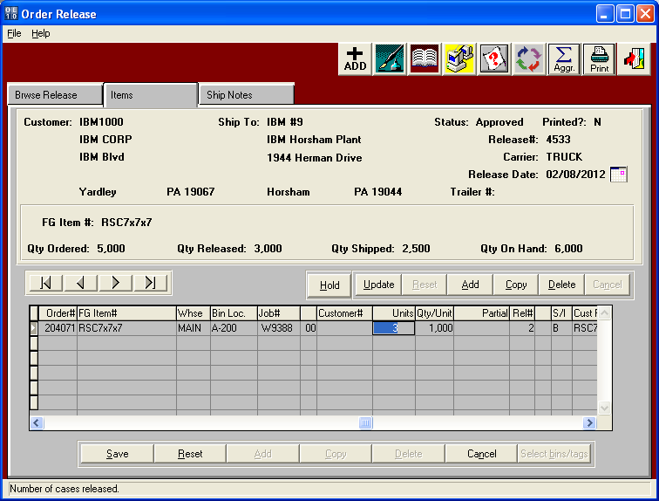

COMMON CARRIER – TRUCK FILE

Each truck in your fleet must be defined in the Common Carrier/Truck file.
Each truck must have the capacity of size, pallets and MSF which will be used in the Truck Load Summary program.

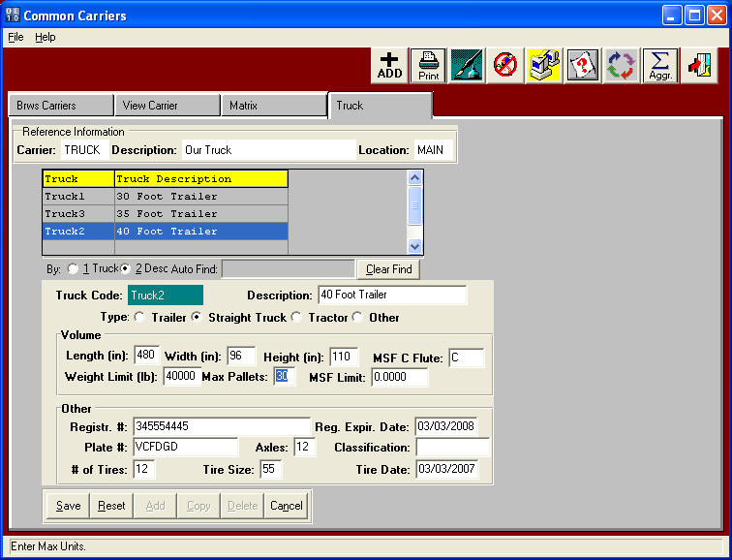

TRUCK LOAD SUMMARY WORKSHEET

The truck load program allows you to select a specific release type within a specific date range, delivery zone, carrier and other criteria. Once selected, the program will list all the deliveries on a worksheet so that you can assign a truck, load number and stop number. The program will provide a warning message if the number of pallets or square footage exceeds the trucks capacity set in the truck file. Once done, print the excel spreadsheet for each truck driver. The business form has columns for the driver to enter the time .

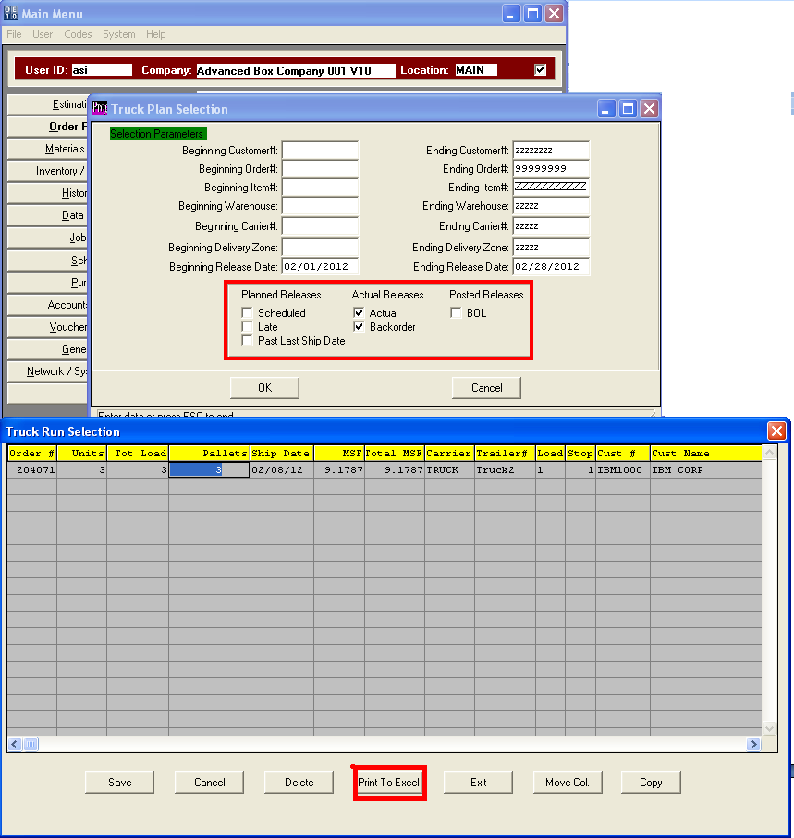

TRUCK LOAD BUSINESS FORM

